SCHOOL OF COMPUTER SCIENCE AND ARTIFICIAL INTELLIGENCE |  |  |  |  | DEPARTMENT OF COMPUTER SCIENCE ENGINEERING
Program Name: B. Tech |  |  |  | Assignment Type: Lab |  |  | Academic Year:2025-2026
Course Coordinator Name |  |  |  | Venkataramana Veeramsetty
Instructor(s) Name |  |  |  | Dr. V. Venkataramana (Co-ordinator)  Dr. T. Sampath Kumar  Dr. Pramoda Patro  Dr. Brij Kishor Tiwari  Dr.J.Ravichander  Dr. Mohammand Ali Shaik  Dr. Anirodh Kumar  Mr. S.Naresh Kumar  Dr. RAJESH VELPULA  Mr. Kundhan Kumar  Ms. Ch.Rajitha  Mr. M Prakash  Mr. B.Raju  Intern 1 (Dharma teja)  Intern 2 (Sai Prasad)  Intern 3 (Sowmya)  NS_2 ( Mounika)
Course Code |  |  | 24CS002PC215 | Course Title |  | AI Assisted Coding
Year/Sem |  |  | II/I | Regulation |  | R24
Date and Day  of Assignment |  |  | Week6 - Monday | Time(s)
Duration |  |  | 2 Hours | Applicable to  Batches
AssignmentNumber:12.1(Present assignment number)/24(Total number of assignments)
NAME: MOTHE JEEVANALAXMI
ROLL NO:2403A51183
BATCH NO:09
 | Q.No. | Question |  |  |  |  |  | Expected Time  to complete
 | 1 | Lab 12: Algorithms with AI Assistance – Sorting, Searching, and Optimizing Algorithms  Lab Objectives:  - Apply AI-assisted programming to implement and optimize sorting and searching algorithms.  - Compare different algorithms in terms of efficiency and use cases.  - Understand how AI tools can suggest optimized code and complexity improvements.  Task Description #1 (Sorting – Merge Sort Implementation)  - Task: Use AI to generate a Python program that implements the Merge Sort algorithm.  - Instructions:  - Prompt AI to create a function merge_sort(arr) that sorts a list in ascending order.  - Ask AI to include time complexity and space complexity in the function docstring.  - Verify the generated code with test cases.  - Expected Output:  - A functional Python script implementing Merge Sort with proper documentation.  CODE:  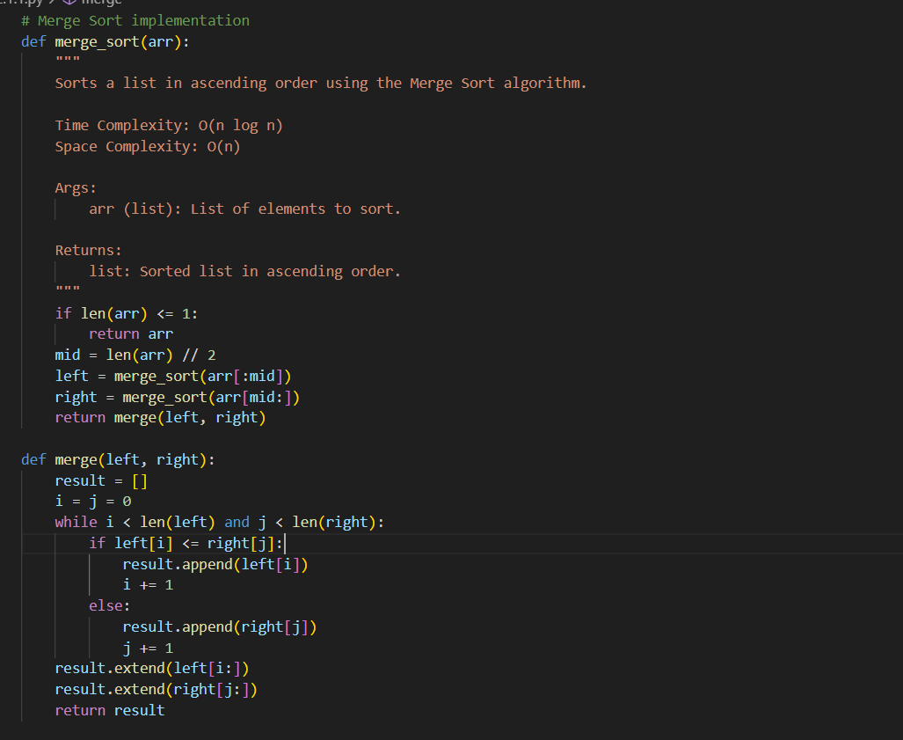  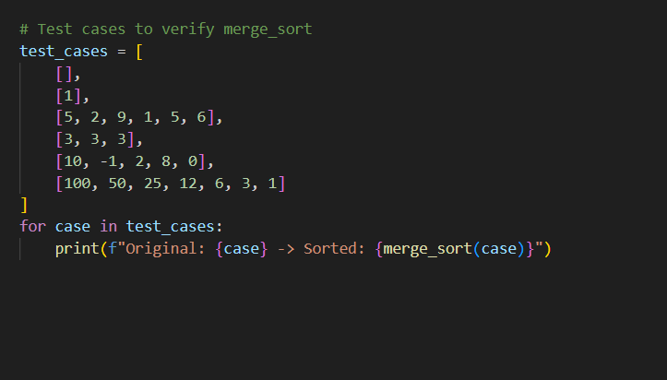  OUTPUT:  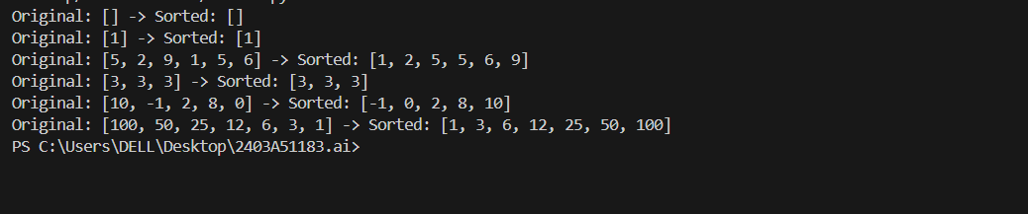  Task Description #2 (Searching – Binary Search with AI Optimization)  - Task: Use AI to create a binary search function that finds a target element in a sorted list.  - Instructions:  - Prompt AI to create a function binary_search(arr, target) returning the index of the target or -1 if not found.  - Include docstrings explaining best, average, and worst-case complexities.  - Test with various inputs.  - Expected Output:  - Python code implementing binary search with AI-generated comments and docstrings.  CODE:  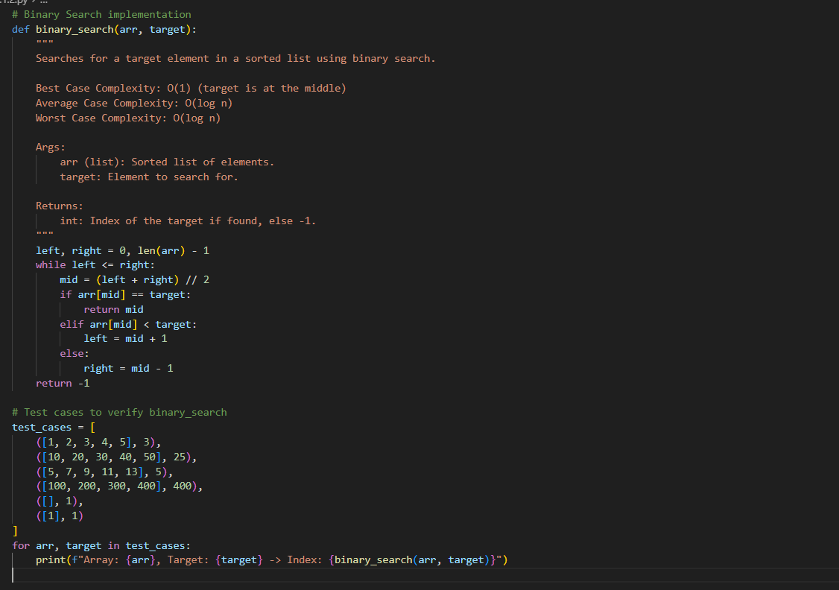  OUTPUT:  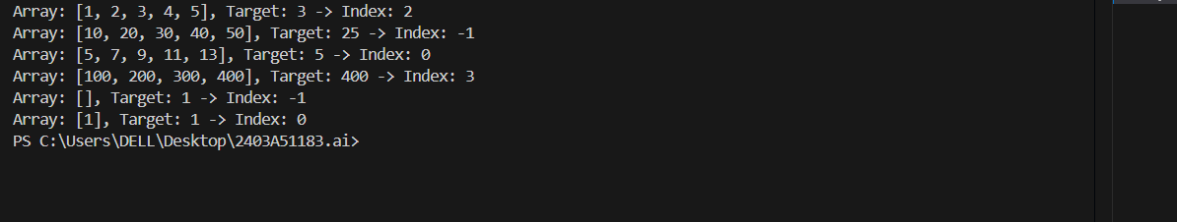  Task Description #3 (Real-Time Application – Inventory Management System)  - Scenario: A retail store’s inventory system contains thousands of products, each with attributes like product ID, name, price, and stock quantity. Store staff need to:  - Quickly search for a product by ID or name.  - Sort products by price or quantity for stock analysis.  - Task:  - Use AI to suggest the most efficient search and sort algorithms for this use case.  - Implement the recommended algorithms in Python.  - Justify the choice based on dataset size, update frequency, and performance requirements.  - Expected Output:  - A table mapping operation → recommended algorithm → justification.  - Working Python functions for searching and sorting the inventory.  CODE:  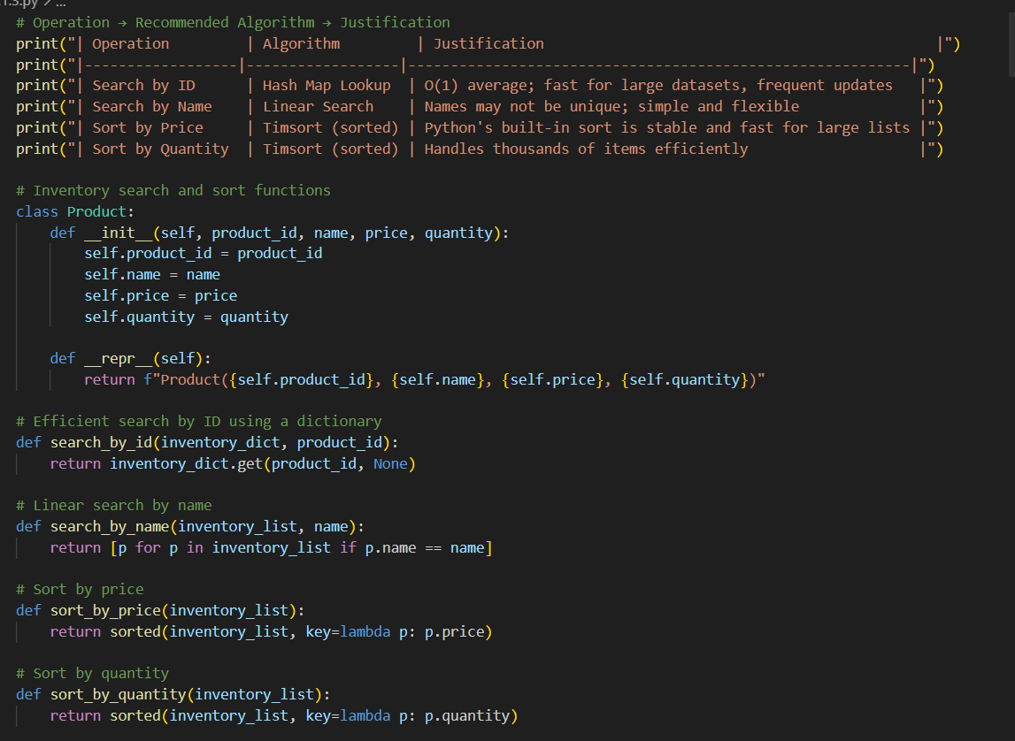  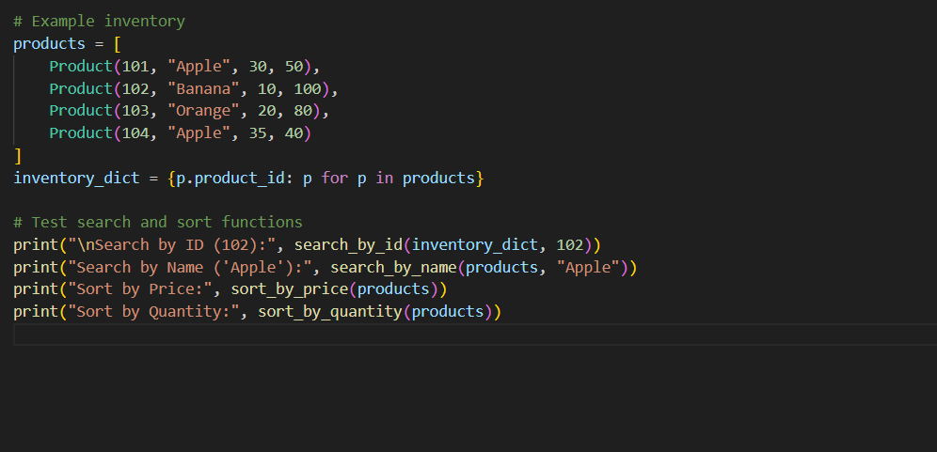  OUTPUT:  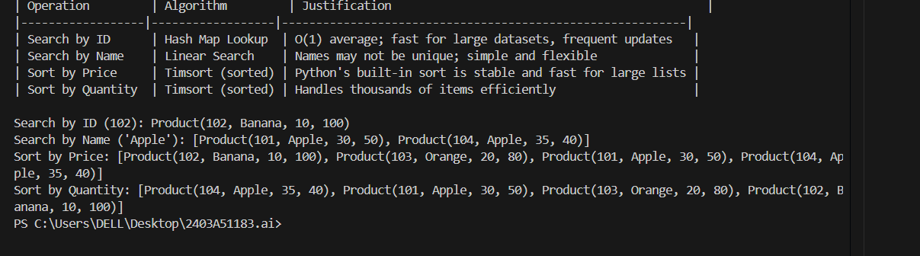  ✅ Deliverables (For All Tasks)  - AI-generated prompts for code and test case generation.  - At least 3 assert test cases for each task.  - AI-generated initial code and execution screenshots.  - Analysis of whether code passes all tests.  - Improved final version with inline comments and explanation.  - Compiled report (Word/PDF) with prompts, test cases, assertions, code, and output. |  |  |  |  |  | Week6 - Monday

